**25-01-2018**

**RESEARCH INFOTECH**

**DAILY ANALYSIS**

|  |
| --- |
| http://researchinfotech.co.in/storage/images/logo.pngImage result for SEBI |

|  |
| --- |
| **FINOLEX CABLES LTD (NSE-FINCABLES)** |

|  |  |  |
| --- | --- | --- |
| **BUY** | **735-736** | **SL-700** |
| **TGT 1- 760** | **TGT 2- 800** | **SL-700** |

|  |  |  |  |  |
| --- | --- | --- | --- | --- |
| **S2** | **S1** | **PP** | **R1** | **R2** |
| **640** | **690** | **730** | **760** | **820** |

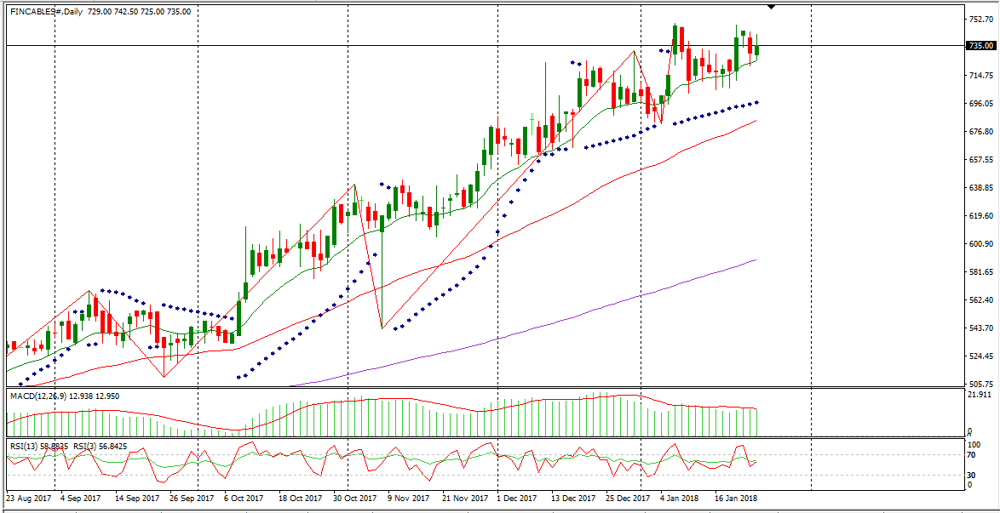

**DESCRIPTION**

Finolex Cables Limited is a manufacturer of electrical and communication cables, and copper rods.   
The Company's business segments include Electrical Cables, Communication Cables, Copper Rods and Others.   
The Electrical Cables segment includes 1,100 Volts polyvinyl chloride (PVC) insulated cables; motor winding PVC insulated cables and approximately three core flat cables; automotive/battery cables, and elevator cables. The Communication Cables segment includes jelly filled telephone cables (JFTCs), local area network cables, coaxial cables, speaker cables, optic fiber cables and closed-circuit television (CCTV) cable. The Copper rods segment offers continuous cast copper (CCC) rods of over eight millimeters diameter.   
The Others segment includes Electrical Switches, which include switches, sockets and regulators, and Lamps, which include retrofit and non-retrofit compact fluorescent lamps (CFL), as well as T5 Tube Lights fittings and light-emitting diode base lighting switches.

|  |
| --- |
| http://researchinfotech.co.in/storage/images/logo.pngImage result for SEBI |

**TECHNICAL VIEW**

* In daily candle FINCABLES was looking strong, it was taking support of its 55 day’s EMA and looking bullish.
* From the opening it was moving up but in 15 minute candle stick, it took support of its short term moving average and I saw fresh buying near closing.
* In short term its structure was also looking bullish.
* In daily candle it was taking support of its day’s low also and looking reversal, next trading it can be gap up opening.
* Above its moving avg it made a bullish candle in daily candle stick chart pattern.
* Its daily trend and its rally was also looking BULLISH.

**RECENT NEWS**

* FINOLEX CABLES LTD. (FINCABLES.BO) market momentum is building as the Awesome Oscillator (AO) is showing an uptrend in the name over the past 5 bars. Awesome Oscillator shows the difference in between the 5 SMA and 34 SMA. If to be precise, 5 SMA of midpoints is subtracted from 34 SMA of midpoints which allows to see the market momentum. Awesome Oscillator buy signals are created when the indicator crosses from below 0 to above 0. The oscillator changes from green (upward movement) to red (downward movement) and back to green again. The oscillator was developed by Bill Williams and outlined in his book titled “New Trading Dimensions”.
* FINOLEX CABLES LTD. (FINCABLES.BO)’s Williams %R presently stands at -29.96. The Williams %R oscillates in a range from 0 to -100. A reading between 0 and -20 would indicate an overbought situation. A reading from -80 to -100 would indicate an oversold situation. Looking at some moving average levels on shares of FINOLEX CABLES LTD.
* (FINCABLES.BO), the 200-day is at 567.31, the 50-day is 683.90, and the 7-day is sitting at 723.79. Moving averages can help identify trends and price reversals. They may also be used to help spot support and resistance levels. Moving averages are considered to be lagging indicators meaning that they confirm trends. A certain stock may be considered to be on an uptrend if trading above a moving average and the average is sloping upward. On the other side, a stock may be considered to be in a downtrend if trading below the moving average and sloping downward.

## **DISCLOSURE**

RESEARCH INFOTECH DO NOT RECEIVE ANY CONSIDERATION BY WAY OF REMUNERATION OR COMPENSATION OR IN ANY OTHER FORM WHATSOEVER, BY US OR ANY OF OUR ASSOCIATES OR SUBSIDIARIES FOR ANY DISTRIBUTION OR EXECUTION SERVICES IN RESPECT OF THE PRODUCTS OR SECURITIES FOR WHICH THE INVESTMENT ADVICE IS PROVIDED TO THE CLIENT.

RESEARCH INFOTECH DO NOT RECOMMEND A STOCK/COMMODITY BROKER. IF ANY STOCK/COMMODITY BROKER IS RECOMMENDED BY ANY OF OUR REPRESENTATIVE, WE DO NOT RECEIVE ANY CONSIDERATION BY WAY OF REMUNERATION OR COMPENSATION OR IN ANY OTHER FORM WHATSOEVER FROM STOCK/COMMODITY BROKER OR ANY OTHER INTERMEDIARY SO RECOMMENDED TO CLIENT.

TO ENSURE COMPLIANCE WITH THE INVESTMENT ADVISOR REGULATIONS 2013, WE HAVE RESOLVED THAT THE INVESTMENT ADVISOR AND ALL ITS REPRESENTATIVES WILL NOT MAKE ANY TRADES IN THE MARKET. WE ARE NOT ASSOCIATED IN ANY MANNER WITH ANY ISSUER OF PRODUCTS/ SECURITIES, THIS ENSURES THAT THERE IS NO ACTUAL OR POTENTIAL CONFLICTS OF INTEREST. THIS ALSO ENSURES THAT OBJECTIVITY OR INDEPENDENCE IN THE CARRYING ON OF INVESTMENT ADVISORY SERVICES IS NOT COMPROMISED. INVESTMENT IN STOCK/COMMODITY MARKETS IS SUBJECT TO MARKET RISK, THOUGH BEST ATTEMPTS ARE MADE FOR PREDICTING MARKETS, BUT NO SURETY OF RETURN OR ACCURACY OF ANY KIND IS GUARANTEED, WHILE THE PERFORMANCE SHEET OF VARIOUS PRODUCTS IS AVAILABLE BUT SHOULD NOT BE CONSIDERED AS A GUARANTEE FOR FUTURE PERFORMANCE OF THE PRODUCTS/SERVICES. CLIENTS ARE ADVISED TO CONSIDER ALL THE ADVICE AS JUST AN OPINION AND MAKE INVESTMENT DECISION ON THEIR OWN.

IN CASE OF CLIENTS SEEKING ADVICE ON ANY SPECIFIC POSITIONS ALREADY MADE BY THE CLIENT, WE WILL BE ABLE TO SUGGEST BEST POSSIBLE ACTION CONSIDERING OUR VIEW ON THE SECURITY OR PRODUCT. SUCH SUGGESTION UNDER ANY CIRCUMSTANCES SHALL BE CONSIDERED AS AN OPINION (NOT ADVICE) FROM OUR ORGANIZATION AND WE ADVISE CLIENT TO CONSIDER OUR OPINION AND NOT CONSULTANCY TO MAKE HIS/HER FINAL DECISION. WE ARE NOT LIABLE FOR ANY LOSSES WHATSOEVER CLIENT MAY INCUR IN ACCEPTING THIS OPINION.

CLIENT IS ALSO ADVISED TO TRADE ONLY IF TIPS SUIT HIS CURRENT RISK APPETITE AND RISK BEARING CAPACITY, ALL SUCH TIPS SHALL BE CONSIDERED AS A VIEW OR OPINION AND CLIENT SHALL ON HIS/HER DISCRETION DECIDE ACTUAL TRADES.

WE ARE NOT ASSOCIATED WITH ANY INTERMEDIARIES AND DO NOT RECOMMEND SERVICES OF ANY SPECIFIC INTERMEDIARIES.  
NO LITIGATIONS HAVE BEEN FILED AGAINST US SINCE THE INCORPORATION.

ALL THE TIPS WHICH ARE SUGGESTED BY US ARE COMMUNICATED IN WRITTEN, NO VERBAL COMMUNICATION FROM ANY OF THE EXECUTIVES OR OTHERWISE UNDER ANY CIRCUMSTANCES SHALL BE CONSIDERED AS ADVICE BY OUR ORGANIZATION.